Progress Report

United Nations Development Programme
Bhutan
HCFC Phase-out Management Plan for Bhutan – UNDP Component: [BHU/PHA/63/INV/17]
2025



Reporting Period | 2025
Donor | MLF
Country | Bhutan
Project Title | HCFC Phase-out Management Plan for Bhutan – UNDP Component: [BHU/PHA/63/INV/17]
Project ID  (Atlas Award ID)  Outputs  (Atlas Project ID and Description)  Strategic Plan and/or CPD Outcomes | 00065284
Implementing Partner(s) | National Ozone Unit, Department of Environment and Climate Change
Project Start Date | 01/01/2013
Project End Date | 31/12/2025
[2025] Annual Work Plan Budget | USD 19,000
Total resources required | 19,000
Revenue received | - Regular USD 19,000  - Other  - Donor USD  - Trust Fund Cost Sharing USD  - Thematic Trust Fund C/S USD  - Special Activities USD  - EU funding USD  - Total USD 19,000
Unfunded budget | USD
UNDP Contact Person | Kunzang Wangmo  Program Analyst  Email: kunzang.wangmo@undp.org  Tel.: 97517631069
Table of Content

I. Executive summary 3
II. Background 3
III. Progress Review 3
IV. Project Risks and Issues 3
a. Updated project risks and actions 4
b. Updated project issues and actions 4
V. Lessons Learned 4
VI. Conclusions and Way Forward 5
VII. Financial Status 6
VIII. Annex 7

- Executive summary
The HCFC Phase-out Management Plan (HPMP), implemented by the National Ozone Unit (NOU) under the Department of Environment and Climate Change (DECC) with UNDP as the implementing agency for the investment component, has successfully achieved Bhutan’s 2025 HCFC consumption target under the Montreal Protocol.
In 2025, Bhutan recorded HCFC consumption of 122 kg (0.122 metric tonnes), equivalent to 0.007 ozone-depleting potential (ODP) tonnes. This meets the final phase-out target established under the HPMP Agreement. Despite higher import requests during the year, the NOU strictly enforced the licensing and quota system, limiting approved imports to remain within the allowable ceiling. This achievement marks a transformational reduction from the baseline of 0.31 ODP tonnes and demonstrates effective regulatory enforcement, market discipline, and institutional coordination. The results were reported to the Multilateral Fund Secretariat through the Country Programme report on 30 March 2026 and will be submitted as Article 7 data to the Ozone Secretariat in June 2026.
Under the UNDP component, a National Implementation Modality (NIM) advance of Nu. 1,542,780 was released to support procurement of servicing tools and equipment for recovery and safe handling of refrigerants. The NOU completed procurement of key equipment, including vacuum pumps, recovery machines, leak detectors, and gauge manifolds. These tools strengthen the capacity of the refrigeration and air-conditioning (RAC) sector to adopt safe servicing practices and prepare for low-global warming potential (GWP) and flammable refrigerants.
Although minor implementation challenges were encountered, including delays in technical validation and budget prioritization, these did not affect achievement of planned outputs or compliance targets. Adaptive management and close coordination between NOU, Customs, and UNDP ensured timely completion of activities.
The HPMP has delivered measurable regulatory, technical, and institutional transformation. With full compliance achieved, Bhutan is now positioned to transition toward implementation of the Kigali Amendment. Continued investment in servicing sector capacity, accurate data reporting, and technical expertise will be critical to sustaining compliance and advancing climate-friendly refrigerant management.

- Background

Bhutan’s HCFC Phase-out Management Plan (HPMP) is implemented under the Montreal Protocol to ensure the systematic reduction and eventual phase-out of hydrochlorofluorocarbons (HCFCs) in line with internationally agreed control schedules. The project is executed by the National Ozone Unit (NOU) under the Department of Environment and Climate Change (DECC), with UNDP serving as the implementing agency for the investment component. The HPMP focuses on strengthening regulatory enforcement, enhancing servicing sector capacity, promoting recovery and reclamation practices, and supporting the transition to environmentally sustainable refrigerant alternatives.
Bhutan established a baseline HCFC consumption of 0.31 ODP tonnes and committed to an accelerated phase-out schedule, targeting near-zero consumption by 1 January 2025. Through a licensing and quota system, capacity-building of refrigeration and air-conditioning (RAC) technicians, and investment in recovery and reclamation equipment, the project aims to ensure compliance while minimizing economic disruption to the servicing sector.
Since the approval of the HPMP, the national context has evolved significantly. Bhutan has now achieved its 2025 HCFC consumption target of 0.007 ODP tonnes, demonstrating effective import control and sectoral compliance. The country is concurrently transitioning toward the phasedown of hydrofluorocarbons (HFCs) under the Kigali Amendment. This transition has shifted the project focus toward safe adoption of low-global warming potential (GWP) and flammable refrigerants, strengthening technical capacity, and improving refrigerant management practices. The integration of recovery, reclamation, and safe handling tools under the UNDP component supports both the completion of HCFC phase-out commitments and readiness for Kigali Implementation Plan (KIP) Stage I.
The project therefore continues to play a critical role in sustaining compliance with Montreal Protocol obligations while supporting Bhutan’s broader climate mitigation efforts through improved refrigerant management and servicing sector transformation.

- Progress Review
1. Achievement of HCFC Phase-out Target
The most significant outcome achieved under the HPMP in 2025 is Bhutan’s successful attainment of the final HCFC consumption target of 0.007 ODP tonnes, in full compliance with the Montreal Protocol phase-out schedule. For 2025, total reported HCFC consumption was 122 kg (0.122 metric tonnes), which corresponds exactly to 0.007 ODP tonnes using the ODP conversion factor.
The National Ozone Unit (NOU) strictly enforced the licensing and quota system, limiting approved imports to 122 kg despite higher import requests during the year. This proactive quota control ensured that Bhutan remained within its allowable consumption ceiling and achieved complete compliance with its HPMP commitments.
This result demonstrates a transformational shift from baseline consumption of 0.31 ODP tonnes to near-zero consumption, reflecting strengthened regulatory enforcement, improved monitoring systems, and sector-wide behavioral change among importers and servicing technicians.
The achievement was formally reported to the Multilateral Fund Secretariat through the Country Programme (CP) report on 30 March 2026, and will be reported as Article 7 data to the Ozone Secretariat in June 2026, fulfilling international reporting obligations.
2. Strengthening Servicing Sector Capacity
In alignment with the 2025 Annual Work Plan (AWP), the UNDP component supported the procurement and distribution of servicing tools and equipment to strengthen safe refrigerant handling practices and prepare the RAC sector for flammable, low-GWP alternatives.
A total NIM advance of Nu. 1,542,780 was released to the government counterpart (NOU) for execution of planned activities. The NOU completed procurement of prioritized equipment, including:
- 20 two-stage vacuum pumps
- 20 flammable refrigerant leak detectors
- 20 four-way gauge manifolds
- 20 capillary tube cutters
- 2 portable recovery machines
These tools directly support refrigerant containment, leak detection, recovery, and safe servicing practices. The intervention enhances national readiness for the safe adoption of flammable refrigerants, bridging HCFC phase-out and Kigali HFC phase-down implementation.
This represents a qualitative transformation in servicing standards — shifting from conventional practices to safety-oriented, containment-based servicing aligned with international best practices.
3. Institutional and Technical Capacity Enhancement
The project strengthened institutional capacity through:
Engagement of an international RAC technical expert for equipment specification and needs assessment;
- Consultations with private technicians and importers;
- Technical validation of equipment requirements in collaboration with the Technical Training Institute (TTI);
- Improved coordination between NOU and servicing stakeholders.
- These actions have enhanced national technical preparedness and reduced reliance on ad-hoc servicing practices. The groundwork laid under this tranche also supports upcoming Kigali Implementation Plan (KIP) Stage I activities.
4. Alignment with CPD, UNDP Strategic Plan and IRRF
The HPMP results directly contribute to:
UNDP Country Programme Document (CPD) Outcome: Environmental sustainability and climate resilience strengthened;
UNDP Strategic Plan Signature Solution 3: Climate change mitigation and sustainable development pathways;
Integrated Results and Resources Framework (IRRF): Reduced greenhouse gas emissions through improved refrigerant management and strengthened national compliance systems.

By achieving complete compliance with the 2025 HCFC target and strengthening servicing sector capacity, the project contributes to global ozone layer protection while advancing climate mitigation through reduced emissions of ozone-depleting substances.
5. Transformational Change Achieved
The project has delivered measurable transformational change across three levels:
- Regulatory Transformation: From controlled reduction to full compliance with phase-out targets.
- Market Transformation: Strict quota enforcement reshaped import behavior and aligned market demand with national targets.
- Technical Transformation: Introduction of specialized tools for flammable refrigerants elevates servicing standards and supports long-term sustainability.
Bhutan’s achievement of the 2025 target ahead of the global HCFC phase-out deadline demonstrates strong national ownership, effective coordination between NOU and UNDP, and sustained commitment to environmental compliance.
- Project Risks and Issue

- Updated project risks and actions

Overall, the risks identified in the Project Document remained manageable and did not materially affect the achievement of project outcomes. Adaptive management, close coordination between UNDP and the National Ozone Unit, and proactive regulatory enforcement ensured that implementation remained on track.
While some implementation challenges were encountered, they did not significantly affect overall project delivery or achievement of targets, and were addressed through timely mitigation measures.
1. Risk: Delay in Technical Specification and Procurement
The ProDoc anticipated risks related to limited in-country technical expertise and potential delays in procurement of specialized servicing tools. During the reporting period, the engagement of an international RAC expert took longer than initially planned, resulting in a shift of implementation from Q4 2025 to Q1 2026.
Mitigation Action:
The National Ozone Unit (NOU) expedited the technical consultations and procurement process once the expert was onboarded. Close coordination with the Ministry for budget release and proactive follow-up ensured completion of procurement by February 2026. The delay did not affect achievement of output targets under the Annual Work Plan (AWP).
Current Status: Risk effectively managed; procurement completed and tools deployed.
2. Risk: Budget Constraints and Cost Variations
The estimated procurement budget exceeded the available tranche allocation. This created a potential risk of incomplete activity implementation.
Mitigation Action:
The NOU prioritized essential equipment that directly supports refrigerant containment and safe handling of flammable alternatives. Non-critical items (valve core removal tools and burr remover tools) were deferred and earmarked for inclusion under the Kigali Implementation Plan (KIP) Stage I.
Current Status: Scope adjusted without compromising intended outcomes; no impact on overall servicing capacity strengthening.
3. Risk: Non-Compliance with HCFC Consumption Targets
A key risk under the HPMP framework is potential exceedance of annual HCFC consumption ceilings, which could trigger funding penalties under the Multilateral Fund agreement.
Mitigation Action:
The NOU maintained strict enforcement of the licensing and quota system. Despite higher import requests during the year, approved imports were capped at 122 kg, ensuring consumption remained within the 2025 target of 0.007 ODP tonnes.
Current Status: Fully mitigated; Bhutan successfully achieved its final HCFC consumption target.
4. Risk: Limited Adoption of Good Servicing Practices
The ProDoc highlighted the risk that inadequate tools and technical capacity in the servicing sector could undermine refrigerant containment and recovery efforts.
Mitigation Action:
Through procurement and planned distribution of recovery machines, leak detectors, and servicing tools, the project strengthened practical capacity among independent technicians. Engagement with the Technical Training Institute further supported technical validation and knowledge transfer.
Current Status: Risk reduced; national capacity for safe refrigerant handling strengthened.

- Updated project issues and actions

During the reporting period, several operational and technical issues were encountered. However, all were addressed through timely corrective measures and did not adversely affect achievement of project outcomes or compliance targets.
1. Delay in Engagement of Technical Expert
Issue:
Procurement of servicing tools required technical validation to ensure compatibility with flammable and low-GWP refrigerants. The engagement of an international RAC expert experienced delays, which shifted implementation from the planned Q4 2025 timeline to Q1 2026.
Action Taken:
The National Ozone Unit (NOU), in coordination with UNDP, expedited expert consultations and finalized technical specifications. Procurement processes were fast-tracked once specifications were confirmed, and the tools were successfully procured and reported completed in early 2026.
Result:
The delay did not affect overall delivery of outputs under the Annual Work Plan, and equipment procurement was completed within the reporting cycle.
2. Budget Limitation under Tranche Allocation
Issue:
The estimated procurement budget exceeded the available NIM advance allocation of Nu. 1,542,780. This created a shortfall for certain non-priority tools (valve core removal tools and burr remover tools).
Action Taken:
The NOU prioritized essential equipment directly supporting refrigerant recovery, containment, and flammable refrigerant safety. Deferred tools were strategically earmarked for inclusion under the Kigali Implementation Plan (KIP) Stage I.
Result:
Core project objectives were achieved without compromising technical outcomes. Budget optimization ensured delivery within available resources.
3. Risk of Exceeding HCFC Consumption Ceiling
Issue:
There were requests for HCFC imports exceeding the allowable quota for 2025. Exceeding the quota could have triggered non-compliance under the Montreal Protocol Agreement with the Executive Committee.
Action Taken:
The NOU strictly enforced the licensing and quota system, limiting approved HCFC imports to 122 kg. All excess requests were declined to ensure compliance with the 0.007 ODP tonne target.
Result:
Bhutan successfully achieved the 2025 HCFC consumption target, and compliance was formally reported to the Multilateral Fund Secretariat (CP report, 30 March 2026) and will be reported under Article 7 in June 2026.
4. Limited In-Country Technical Expertise for Emerging Refrigerants
Issue:
Transition toward flammable and low-GWP refrigerants requires enhanced technical knowledge and safe servicing practices. The ProDoc identified capacity constraints in servicing institutions as a long-term risk.
Action Taken:
Procurement of recovery machines, leak detectors, vacuum pumps, and servicing tools was completed to strengthen practical handling capacity. Coordination with the Technical Training Institute supported technical validation and knowledge reinforcement.
Result:
Servicing sector readiness for safe refrigerant transition has improved, supporting both completion of HCFC phase-out and preparation for Kigali phase-down.
5. Inter-Agency Coordination and Reporting Demands
Issue:
Strict annual reporting requirements under Article 7 require accurate data compilation and validation.
Action Taken:
The NOU maintained close coordination with Customs to monitor imports through the licensing system and ensure accurate reporting. Data was compiled and submitted within the prescribed timelines.
Result:
Reporting compliance was achieved without delay, strengthening institutional credibility and transparency.

- Lessons Learned
The implementation of the HPMP investment component during the reporting period offers important lessons for sustaining compliance under the Montreal Protocol and informing future programming under the Kigali Implementation Plan (KIP).
1. Key Project Successes and Enabling Factors
The most significant success of the project was Bhutan’s achievement of the 2025 HCFC consumption target of 0.007 ODP tonnes. This reflects a transformational reduction from the baseline of 0.31 ODP tonnes and demonstrates effective regulatory enforcement and market discipline.
Several factors contributed to this success:
- Strong national ownership: The National Ozone Unit (NOU) exercised strict control over the licensing and quota system, even when faced with higher import requests.
- Early infrastructure investment: Prior investments in vocational training institutes (VTIs), recovery and reclamation systems, and technician capacity created sustained servicing sector readiness.
- Close coordination between NOU and Customs: Real-time monitoring of import volumes ensured compliance with annual ceilings.
- Performance-based implementation modality: The tranche-linked funding mechanism encouraged disciplined implementation and milestone tracking.
These institutional strengths enabled Bhutan not only to meet its compliance target but to do so without economic disruption to the servicing sector.
2. Difficulties Encountered and Mitigation Measures
Some operational challenges were encountered during implementation:
- Delay in engaging technical expertise for specification of servicing tools for flammable refrigerants.
- Budget constraints that required prioritization of essential equipment within available NIM advance funding.
- Dependence on external technical validation for emerging refrigerant technologies.
These difficulties were addressed through expedited procurement processes, scope prioritization, and strategic deferral of non-critical tools to KIP Stage I. Importantly, these issues did not affect achievement of output or outcome targets.
3. What Could Have Been Done Differently
While results were achieved successfully, several improvements could enhance future efficiency:
- Earlier technical planning: Developing in-house technical expertise or pre-approved technical specifications would reduce reliance on external consultants and minimize procurement delays.
- Integrated budget forecasting: More detailed cost projections at planning stage could reduce mid-implementation adjustments.
- Stronger forward-linkage with Kigali transition: Earlier alignment between HCFC phase-out tools and flammable refrigerant transition requirements could have accelerated readiness.
These reflections highlight opportunities for strengthening institutional capacity and anticipatory planning.
4. Recommendations for Future Programming
Based on implementation experience, the following recommendations are proposed for future programming, particularly under the Kigali Implementation Plan:
- Build in-house technical expertise within NOU and partner institutions to reduce dependency on external consultants.
- Institutionalize data-driven planning, using refrigerant import trends to anticipate servicing tool requirements.
- Strengthen integration between regulatory enforcement and servicing sector capacity-building, ensuring smoother refrigerant transition.
- Enhance stakeholder engagement mechanisms, including formation of a RAC technician network or association to sustain good servicing practices.
- Ensure early financial mobilization and phased procurement planning to mitigate budget-related implementation risks.

- Conclusions and Way Forward
The successful achievement of Bhutan’s 2025 HCFC consumption target marks a significant milestone under the Montreal Protocol. Through effective enforcement of the licensing and quota system, targeted investment in servicing sector capacity, and disciplined monitoring and reporting mechanisms, Bhutan reduced HCFC consumption from a baseline of 0.31 ODP tonnes to 0.007 ODP tonnes in 2025. This accomplishment demonstrates strong national ownership, institutional coordination, and sustained commitment to environmental compliance.
The UNDP-supported investment component under the HPMP has played a critical role in strengthening the technical foundation required to sustain these results. Procurement of recovery and servicing tools, enhancement of technician capacity, and improved refrigerant management practices have contributed to long-term sector transformation. Importantly, these efforts have ensured that compliance was achieved without disruption to essential refrigeration and air-conditioning services.
As Bhutan transitions from HCFC phase-out to implementation of the Kigali Amendment, the focus will increasingly shift toward safe adoption of low-global warming potential (GWP) and flammable refrigerants. The experience gained under the HPMP provides a strong institutional and technical platform for this transition. However, continued investment in technical expertise, data accuracy, and servicing sector readiness will be essential.
Way Forward
Moving forward, the following strategic priorities will guide future programming:
- Strengthening Kigali Implementation Plan (KIP) Readiness:
Build on the HPMP foundation to support systematic HFC phase-down, including expansion of safe handling capacity for flammable refrigerants and further procurement of specialized tools.
- Institutionalizing Servicing Sector Standards:
Enhance collaboration with technical training institutes and servicing enterprises to sustain good servicing practices, refrigerant recovery, and containment measures.
- Enhancing Data Integrity and Reporting Systems:
Strengthen coordination with Customs and clearing agents to ensure accurate refrigerant classification and reporting under Article 7 and Country Programme requirements.
- Building In-Country Technical Expertise:
Develop national technical capacity to reduce reliance on external consultants and support anticipatory planning for future refrigerant transitions.
- Promoting Climate Co-Benefits:
Align refrigerant management efforts with Bhutan’s broader climate mitigation commitments, ensuring that future transitions maximize both ozone and climate benefits.
The completion of the HCFC phase-out target represents not an endpoint, but a transition toward more ambitious climate-aligned refrigerant management. Continued partnership between the National Ozone Unit, UNDP, and sector stakeholders will ensure that Bhutan sustains compliance achievements while advancing toward a climate-friendly cooling future.

- Financial Status

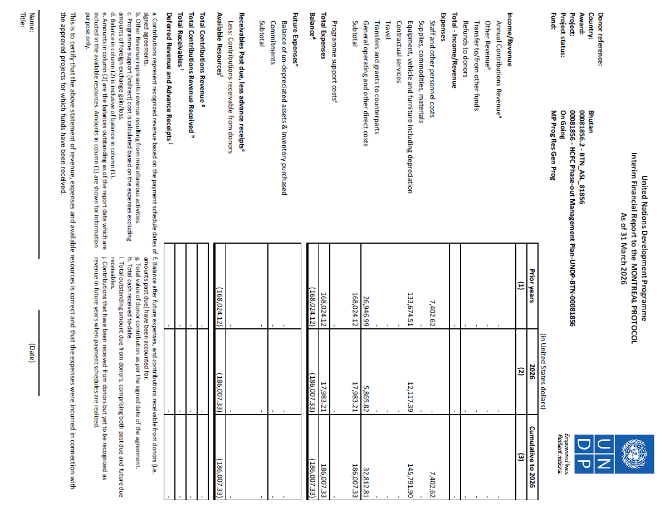

- Annex; Annual Work Plan (AWP),

MLF No. |  | BHU/PHA/95/INV/33
Project Name |  | HCFC phase-out management plan (stage I, fourth tranche)
Quantum Award Number |  | 00081856.2
Quantum Project Number |  | 00081856
EXPECTED CP OUTPUTS  and indicators including 12 months' targets | PLANNED ACTIVITIES  List all activities including M&E to be undertaken during the year towards stated CP outputs |  |  | TIMEFRAME |  |  |  | RESPONSIBLE PARTY | PLANNED BUDGET
 |  |  |  | 2025 |  |  |  | Implementing Partner | Source of Funds | Budget  Description | Amount (US$)
 |  |  | Account Code | Q1 | Q2 | Q3 | Q4 | Implementing Partner | Source of Funds | Budget  Description | 2025 | Total
UNDP outcome 2 (UNSDCF outcome 3). By 2028, Bhutan’s environment remains sustainably managed, and its people are more resilient to disaster risks and climate change | 1 | Recovery and Reclamation Program
 |  | 1.1. Safety Gears for Field officers (4 sets) | 72200 |  |  | X |  | NOU | MLF | Equipment | 4,000.00 | 4,000.00
 |  | 1.2. Recovery Units and Mini-reclaim inventory, and Documentation | 75700 |  |  | X | X | NOU | MLF | Training/workshop | 2,000.00 | 2,000.00
 | 2 | End user/Retrofitting Incentive Programme
 |  | 2.1. ODS Identifier (2 nos) | 72200 |  |  | X | X | NOU | MLF | Equipment | 9,000.00 | 9,000.00
 |  | 2.2. Technical expertise on ODS identifier training | 75700 |  |  | X | X | NOU | MLF | Training/workshop | 2,000.00 | 2,000.00
Sub-total |  |  |  |  |  |  |  |  |  |  | 17,000.00 | 17,000.00
 | Assurance Activities
 | 1 | Quarterly and annual review meetings | 75700 |  | X |  | X | NOU | MLF | Training/workshop | 1,000.00 | 1,000.00
 | 2 | Quarterly and annual review meetings | 75700 |  |  |  | X | UNDP | MLF | Training/workshop | 1,000.00 | 1,000.00
Sub-total |  |  |  |  |  |  |  |  |  |  | 2,000.00 | 2,000.00
TOTAL |  |  |  |  |  |  |  |  |  |  | 19,000.00 | 19,000.00

Disclaimer: Data contained in this financial report section is an extract of UNDP financial records. All financial provided above is provisional.

